Tony Leetham’s Stolen Bikes
Unfortunately I had my garage broken into on 23rd December and three bikes stolen from Hemel Hempstead. I'm trying to contact as many cycle groups in the area as possible to make people aware, in the hope of getting them back!
I would appreciate it if you would be able to let your members know about this and if you could all keep an eye out for them, all are quite distinctive and two unique, as I painted them myself.

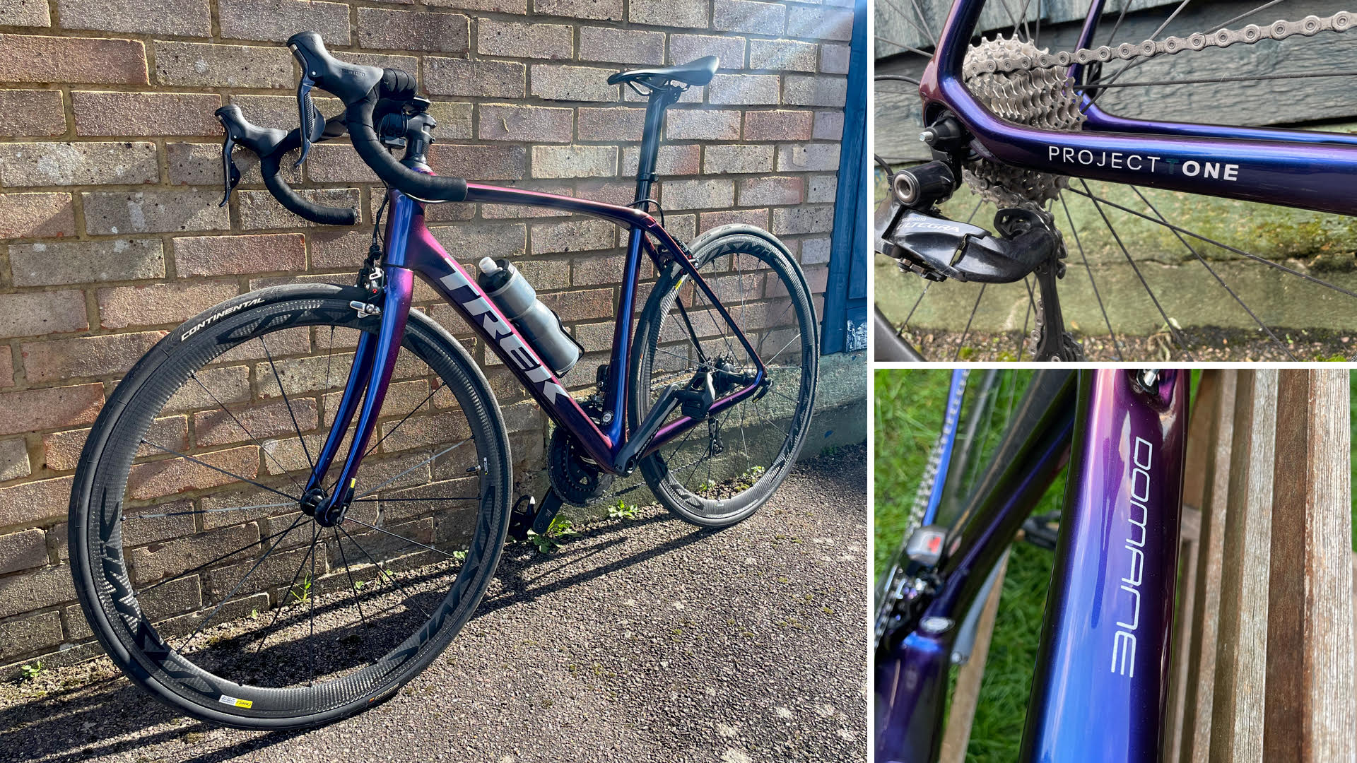Trek Domane, Ultegera Di2, Cosmic Carbone 40 elite wheels, purple/blue colour shift paint.

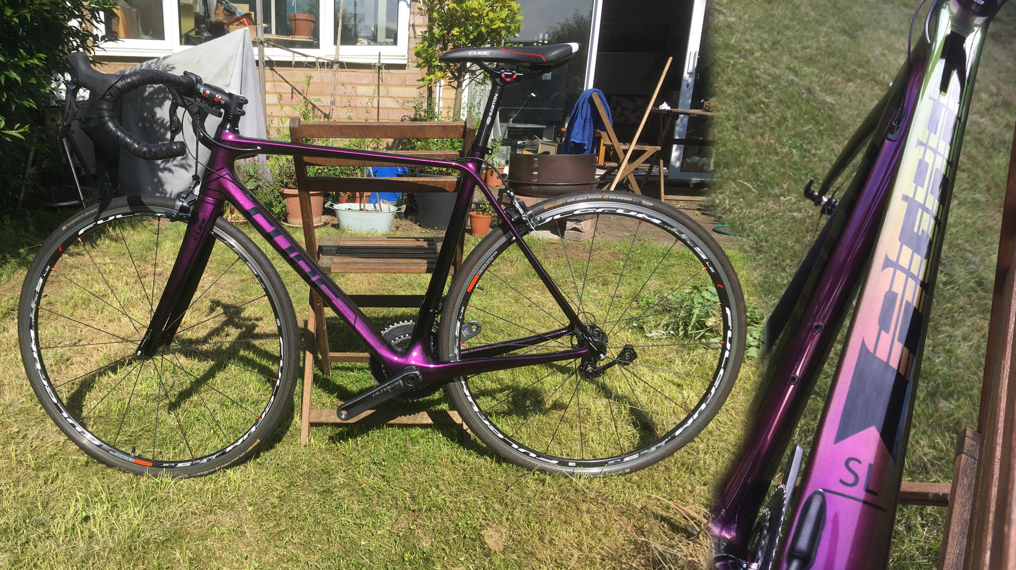
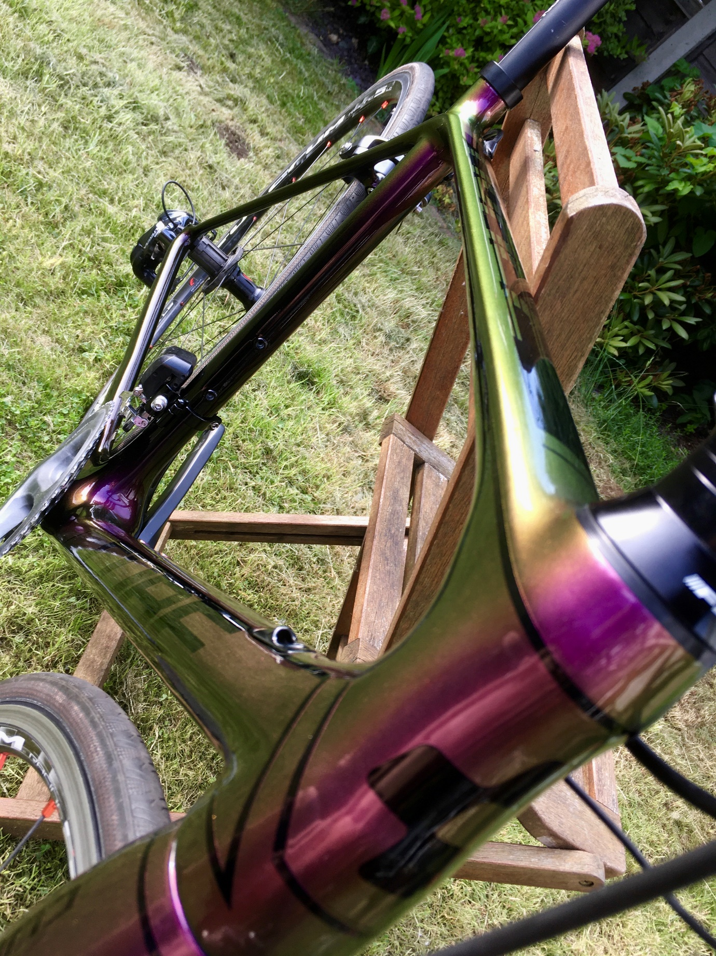
Cube Agree GTC, Ultegra Di2, Pink/red to gold/yellow colour shift paint

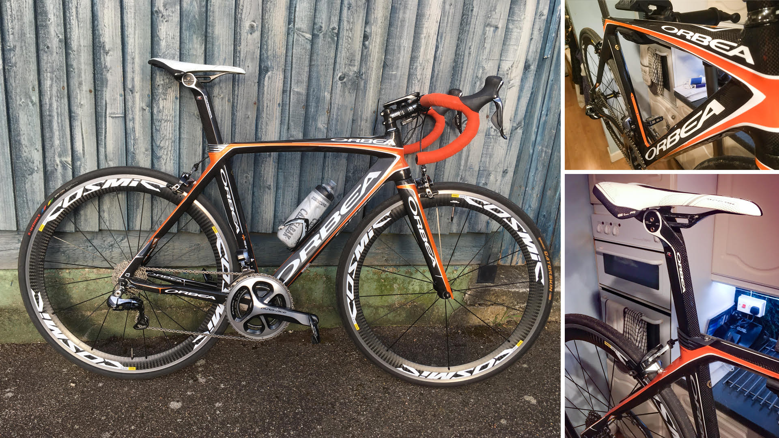
Orbea Orca Gli2, gold level frame with full Dura-ace 9070 groupset Di2, Mavic Cosmic SLS wheelset, Carbon Fibre and orange.
Any information about them would be appreciated as I don't think I'll get much from the police!
Tony
Mob. 07887 523 075

